Configuration 1: Zone-Based Firewall

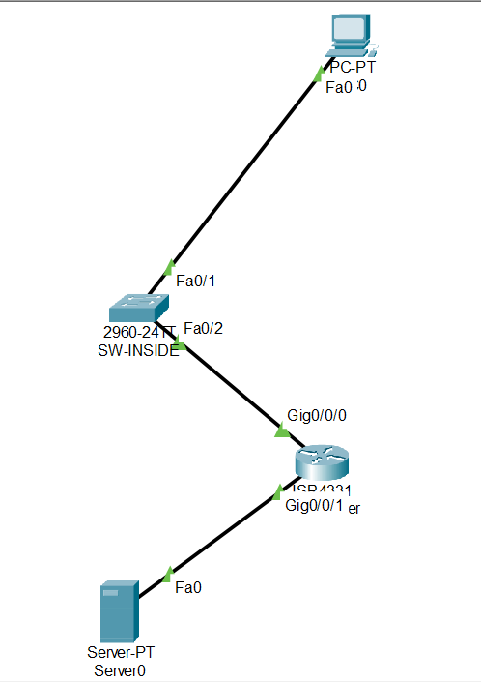

ZBF-01-PC-IP-Configuration.png
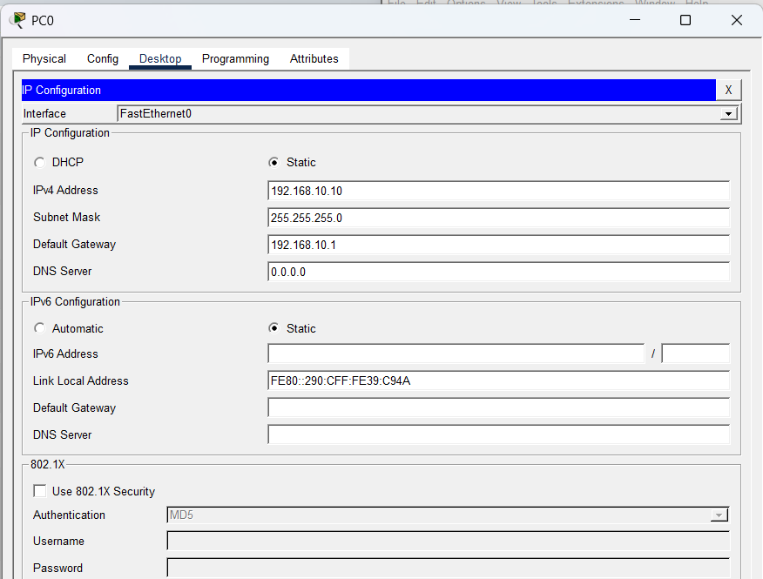

ZBF-02-Server-IP.png
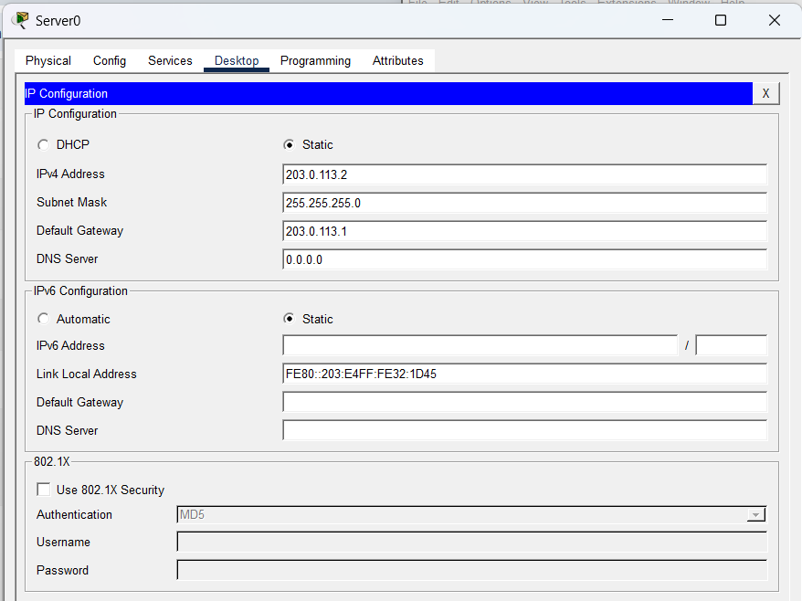

ZBF-03-Router-Interfaces.png
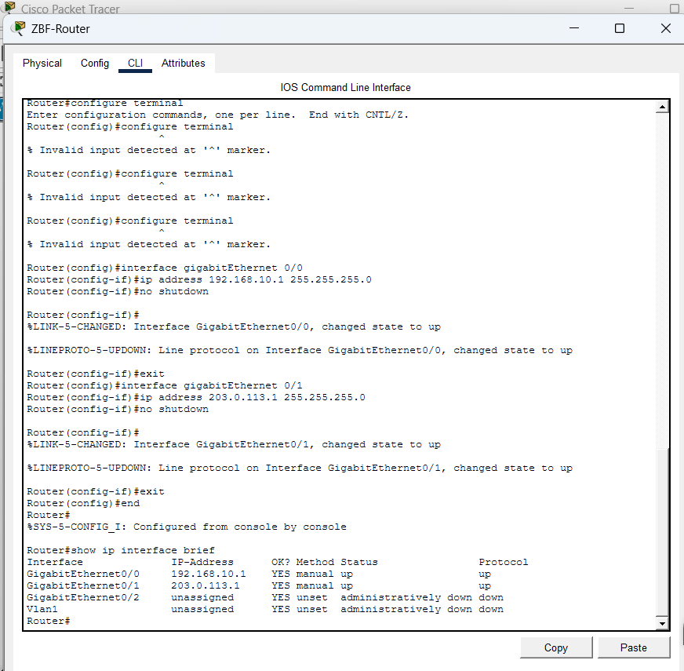

ZBF-04-Basic-Connectivity.png
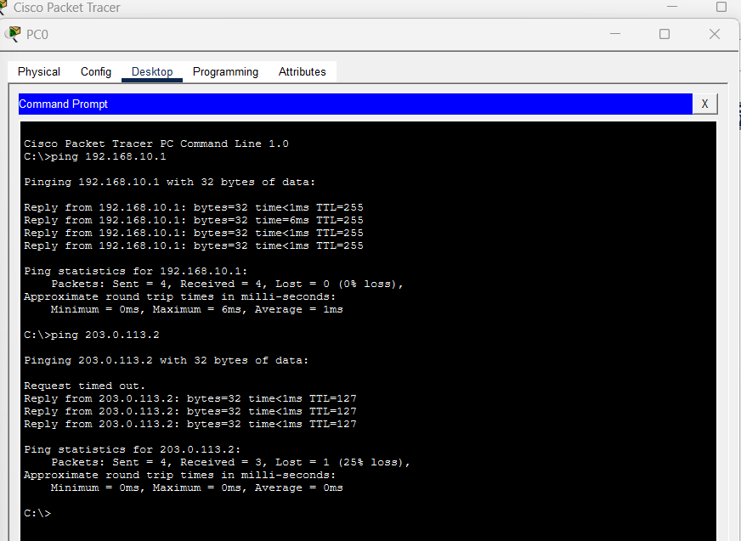

ZBF-02-HTTP-Service.png
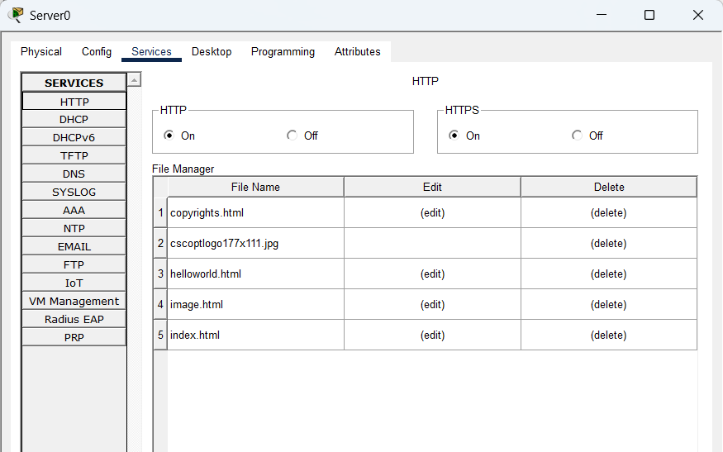

ZBF-05-Before-Firewall-Web-Test.png
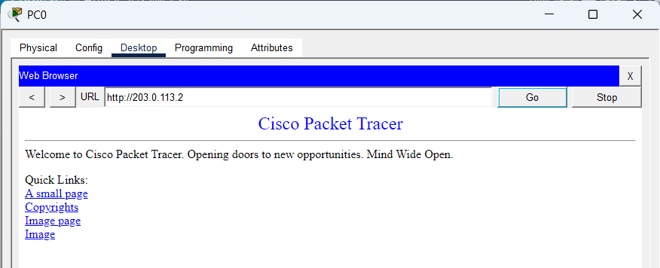

ZBF-08-Zone-Assignment.png
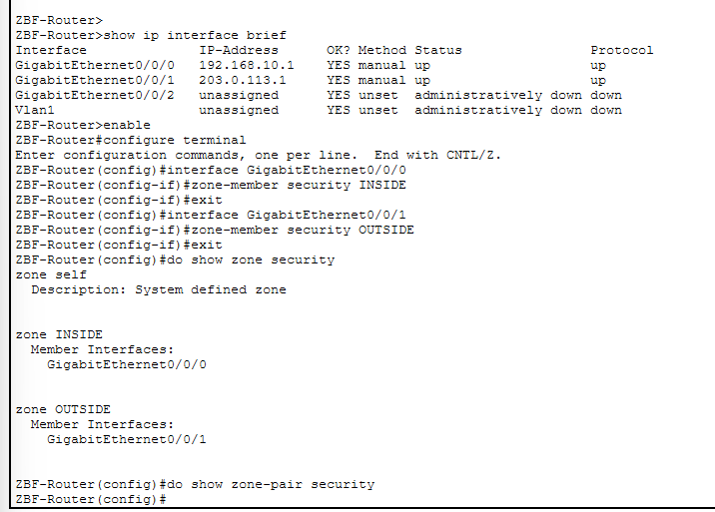

ZBF-Router(config-cmap)#
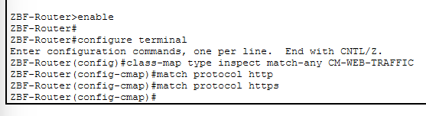

ZBF-Zone-Pair-Verification.png
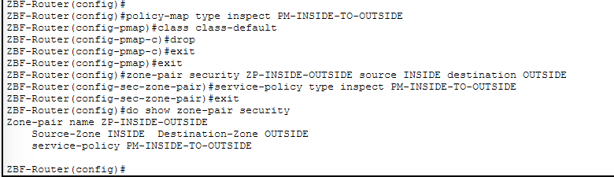
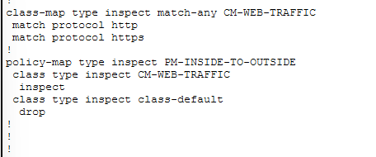
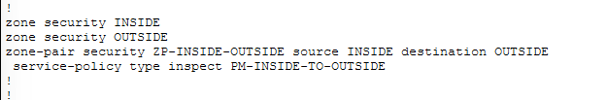
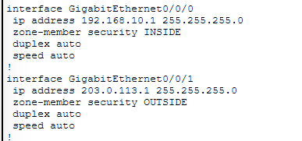

ZBF-09-Zone-Pair-Verification.png
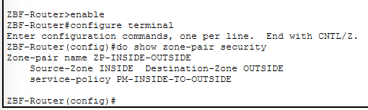

ZBF-10-ICMP-Blocked.png
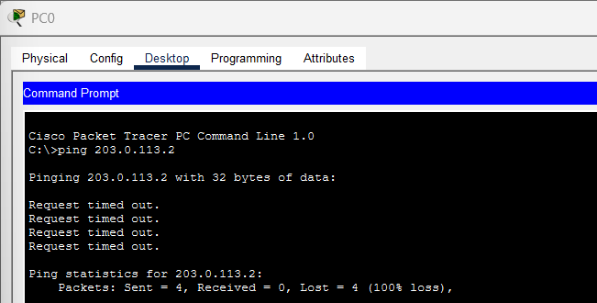

ZBF-11-HTTP-Allowed.png
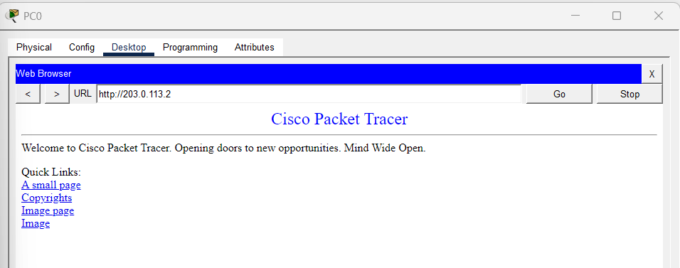

Figure: Successful HTTP traffic through the Zone-Based Firewall. PC0 in the INSIDE zone successfully accesses the web server at 203.0.113.2 in the OUTSIDE zone. HTTP traffic is matched by the CM-WEB-TRAFFIC class-map and inspected by the PM-INSIDE-TO-OUTSIDE policy.

ZBF-12-Policy-Verification.png
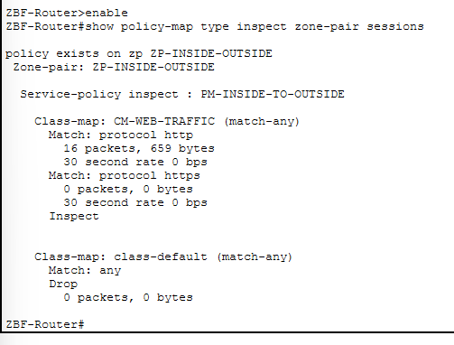
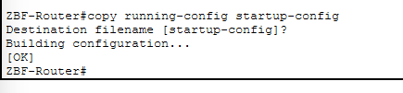

Configuration 2: STP PortFast + BPDU Guard
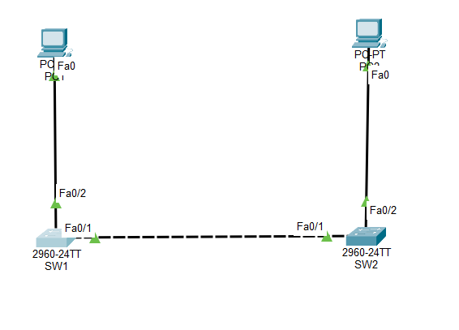

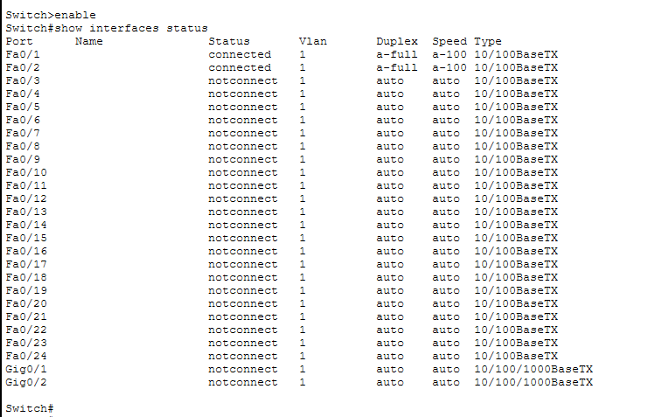

STP-01-Baseline-Ping.png.
baseline connectivity evidence before applying the hardening configuration.
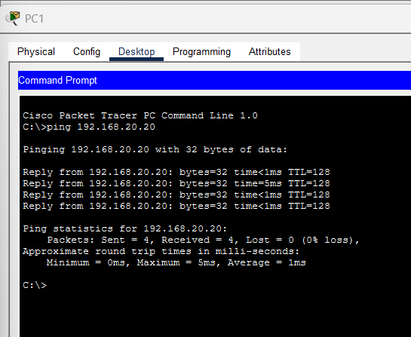

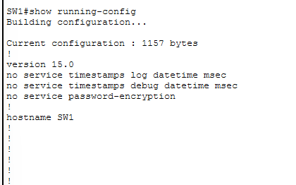
STP-02-SW1-PortFast-BPDUGuard.png
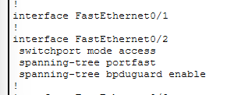

The BPDU Guard message:

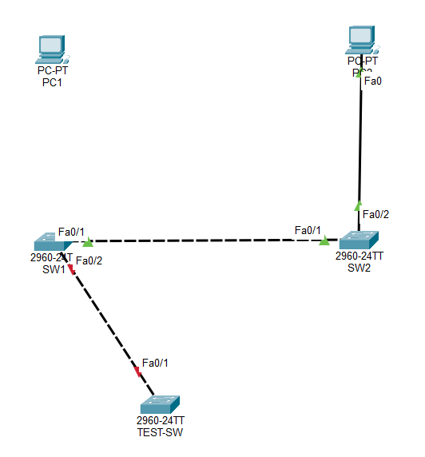

show interfaces status:
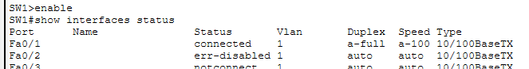

show interfaces FastEthernet0/2:
